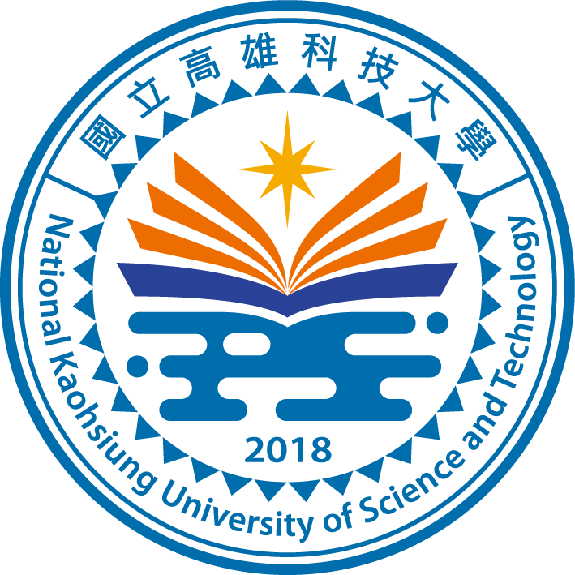

***Memorandum of Agreement on Student Exchange***

*between*

***Name of Faculty,***

***National Kaohsiung University of Science and Technology***

*and*

***Name of Faculty, International HEI***

Based on the *“Memorandum of Understanding between National Kaohsiung University of Science and Technology and Name of International HEI*” signed on Month Date, Year, both parties, namely *Kaohsiung University of Science and Technology* and *Name of International HEI*, have concluded this agreement to specify the student exchange program between the two parties.

1. Number of participating students

Each party shall nominate up to FIVE (5) qualified undergraduate or graduate students per semester to participate in the student exchange program. The Host university may select the exchange participants based on the home university’s recommendations.

1. Enrollment status

Exchange participants shall be registered as non-degree, full-time students at the Host university.

1. Period of Study

The period of study for an exchange is one semester. However, upon the approval of both parties, the period of study could be extended to one academic year.

1. Course registration

Exchange students shall take regular courses offered by the Host university and shall receive priority in course registration. The Host university reserves the right to decline the students’ course registration requests based on its curriculum regulations.

1. Course credits

At the end of the period of study, the Host university shall inform the home university of the course credits and the grades earned by the exchange students. Course credit recognition is the responsibility of the students’ home university.

1. Fees and expenses

Each exchange student will pay his or her regular fees for tuition, registration, admission, and other fees payable to the Home University and will receive the benefits from the Host University that are available for exchange students. All related expenses, including accommodation, transportation, health and accident insurance, and living expenses, shall be borne by the exchange students.

1. Accommodation and insurance

The host university shall undertake efforts to locate housing for the exchange students. Either or both parties may require the exchange students to enroll in recommended health and accident insurance plans.

1. Amendment

This memorandum may be amended only in writing upon the agreement of both parties. In the future, if any issue arises out of or in relation to this memorandum, the two parties shall resolve such issue through negotiation.

1. Term

This memorandum is valid from the joint signature date until the designated termination date set forth in the “*Name of Faculty, National Kaohsiung University of Science and Technology* and *Name of Faculty, International HEI*”. This memorandum may be renewed upon agreement of both parties.

1. Termination

This memorandum may be terminated by either party upon prior written notice to the other party made at least 6 months prior to the expiration date. Even after the related memorandums or agreements are terminated, students who have been accepted under this memorandum are entitled to participate in the relevant study under the same conditions as originally planned.

1. Compliance with laws, rules, and regulations

Both parties shall observe and comply with all laws, rules and regulations of each country in which this memorandum is performed.

1. This memorandum is to be executed in English.

|  |  |
| --- | --- |
|  |  |
|  |  |
| Name of Faculty Head | Name of Faculty Head |
| Name of Faculty, National Kaohsiung University of Science and Technology | Name of Faculty, International HEI |
| Date: | Date: |